实验二
利用栈，计算后缀表达式的值
输入23+，输出5
输入145*+3/3-，输出4
void main()
{
stack S;
int i = 0, sum;
int x, y;
char s[100];
InitStack(&S);
scanf("%s", s);
while (s[i] != '\0')
{
if (s[i] <= '9'&&s[i] >= '0')
Push(&S, s[i] - 48);
if (s[i] == '+')
{
x = Pop(&S, &x);
y = Pop(&S, &y);
sum = x + y;
Push(&S, sum);
}
if (s[i] == '-')
{
x = Pop(&S, &x);
y = Pop(&S, &y);
sum = y - x;
Push(&S, sum);
}
if (s[i] == '*')
{
x = Pop(&S, &x);
y = Pop(&S, &y);
sum = x * y;
Push(&S, sum);
}
if (s[i] == '/')
{
x = Pop(&S, &x);
y = Pop(&S, &y);
sum = y / x;
Push(&S, sum);
}
i++;
}
printf("outcome is %d ", sum);
}

}

运行效果
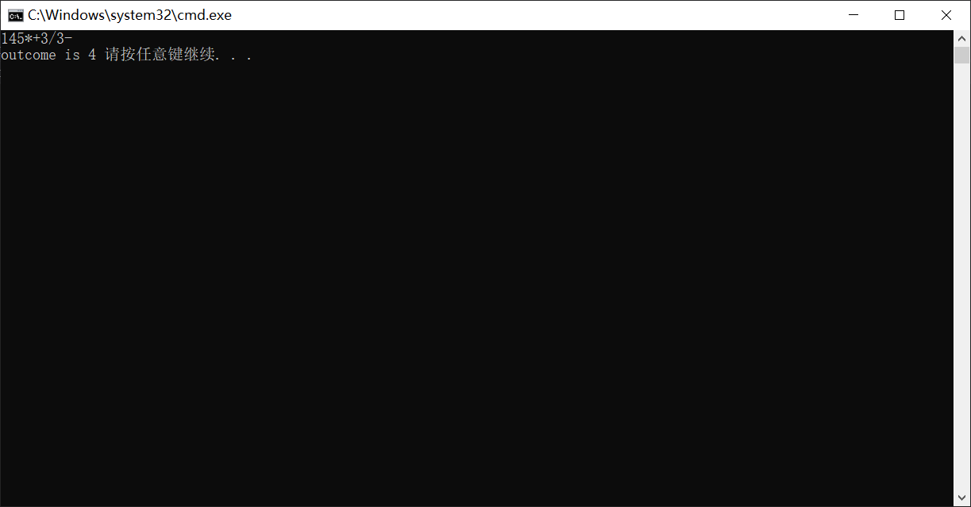

总结：后缀表达式的求值规则为：从左到右扫描后缀表达式，如果遇到操作数，将其压入栈中，如果遇到操作符，则从栈中弹出两个操作数，计算结果，然后把结果入栈，直到遍历完后缀表达式，则计算完成，此时的栈顶元素即为计算结果。

